 | Object Oriented Programming  Practical #5
Name | Chaitanyaa Vaibhav Hegishte | Roll Number | 25302D0038
Subject/Course: | OOP Practical / BSc IT
Practical 5 | Friend function
a. Write a friend function for adding the two complex numbers, using a single class
b. Write a friend function for adding the two different distances and display its sum, using two classes.
c. Write a friend function for adding the two matrix from two different classes and display its sum
d. Write a Program to find Maximum out of Two Numbers using friend function.
Note: Here one number is a member of one class and the other number is member of some other class.

Program:
#include<iostream>
using namespace std;
class Complex
{
float real,imag;
public:
void getdata()
{
cout<<"Enter real and imaginary parts:";
cin>>real>>imag;
}
friend Complex addcomplex(Complex c1,Complex c2);
void showdata()
{
cout<<"Sum="<<real<<"+"<<imag<<"i"<<endl;
}
};
Complex addcomplex(Complex c1,Complex c2)
{
Complex temp;
temp.real =c1.real+c2.real;
temp.imag =c1.imag+c2.imag;
return temp;
}
int main()
{
Complex c1,c2,sum;
c1.getdata();
c2.getdata();
sum=addcomplex(c1,c2);
sum.showdata();
return 0;
}
Output:
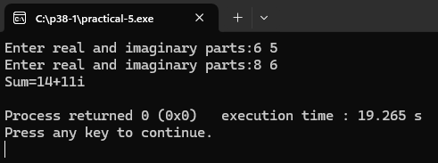

Program:
#include<iostream>
using namespace std;
class Distance1;
class Distance2;
class Distance1
{
int meter;
public:
void getdata()
{
cout<<"Enter distance in meters:";
cin>>meter;
}
friend void addDistance(Distance1 ,Distance2);
};
class Distance2
{
int feets;
public:
void getdata()
{
cout<<"Enter distance in feets:";
cin>>feets;
}
friend void addDistance(Distance1 ,Distance2);
};
void addDistance(Distance1 d1 ,Distance2 d2)
{
float total= d1.meter + (d2.feets *0.3048);
cout<<"Total Distance in meters:"<<total<<"m"<<endl;
}
int main()
{
Distance1 d1;
Distance2 d2;
d1.getdata();
d2.getdata();
addDistance(d1,d2);
return 0;
}
Output:
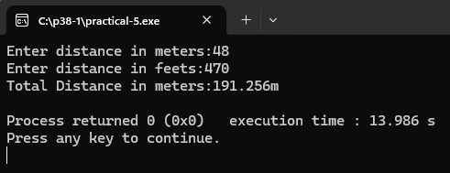

Program:
#include<iostream>
using namespace std;
#define SIZE 2

class Matrix2;
class Matrix1
{
int mat1[SIZE][SIZE];
public:
void getdata()
{
cout<<"Enter elements of first matrix:\n";
for (int i=0;i<SIZE;i++)
for (int j=0;j<SIZE;j++)
cin>>mat1[i][j];
}
friend void addMatrix(Matrix1 ,Matrix2);
};
class Matrix2
{
int mat2[SIZE][SIZE];
public:
void getdata()
{
cout<<"Enter elements of second matrix:\n";
for (int i=0;i<SIZE;i++)
for (int j=0;j<SIZE;j++)

cin>>mat2[i][j];
}
friend void addMatrix(Matrix1 ,Matrix2);
};
void addMatrix(Matrix1 m1,Matrix2 m2)
{
int sum[SIZE][SIZE];
cout<<"Sum of matrices:\n";
for(int i=0;i<SIZE;i++){
for (int j=0;j<SIZE;j++){
sum[i][j]=m1.mat1[i][j]+m2.mat2[i][j];
cout<< sum[i][j]<<"\t";
}cout<<endl;
}}
int main()
{
Matrix1 m1;
Matrix2 m2;
m1.getdata();
m2.getdata();
addMatrix(m1,m2);
return 0;
}
Output:
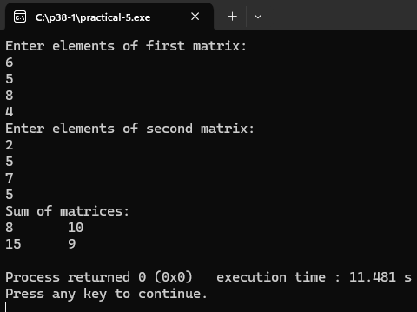
Program:
#include<iostream>
using namespace std;
class Maximum2;
class Maximum1
{
int num1;
public:
void getdata()
{
cout<<"Enter first number:";
cin>>num1;
}
friend void comparemax(Maximum1,Maximum2);
};
class Maximum2
{
int num2;
public:
void getdata()
{
cout<<"Enter second number:";
cin>>num2;
}
friend void comparemax(Maximum1,Maximum2);
};
void comparemax(Maximum1 m1,Maximum2 m2)
{
if(m1.num1>m2.num2){
cout<<m1.num1<<"is maximum";
}else{
cout<<m2.num2<<"is maximum";
}
}
int main()
{
Maximum1 m1;
Maximum2 m2;
m1.getdata();
m2.getdata();
comparemax(m1,m2);
return 0;
}
Output:
